BOSS 3000, the latest version of the classic
Following the launch of the new BOSS 3000 MASTER loader wagons with the innovative EVOMATIC loader unit, Pöttinger is now also launching the BOSS 3000 series featuring the classic SUPERMATIC tine conveyor unit. This move will see the popular and widely used EUROBOSS series being completely replaced in 2023. The new BOSS 3000 is available in three sizes with load capacities of 18.7 m³, 21.3 m³ and 23.5 m³ as both high profile and LowProfile (LP) versions.

SUPERMATIC – the classic loading unit
The tine conveyor system originating from the EUROBOSS is known for very high forage conservation combined with the lowest power requirement. The loading system can be ordered with three or four arms, which can also be used to load heavy silage. The loader wagons are driven as standard at 540 rpm at the PTO, and can be operated by tractors as small as 60 hp. Above that, up to 110 hp is also possible. As an option, the driveline is also available for a PTO speed of 1,000 rpm. As standard, the BOSS is equipped without knives. Six knives can be slotted in as an option. The knife bank with 16 or 31 knives can be folded out by an optional hydraulic system and then swung out alongside using EASYMOVE. All the knives are individually protected against foreign objects.

Pick-up Pöttinger style
The pick-up with an effective width of 1800 mm (DIN) has a freedom of movement of 120 mm at the outermost tine. In especially demanding terrain, a trailing jockey wheel chassis further improves ground tracking. Ground tracking can also be optimised with the AUTOTAST active parallel lift drawbar. The five pick-up tine carriers, which are guided by a cam track, are driven by a maintenance-free V-belt.

Simply ingenious
The hydraulically dry forage extension can now be equipped with an automatic folding system. Optional nets prevent the crop from snagging or falling out between the struts. For longer working days, an LED lighting package is also available.

ISOBUS for all
In addition to ISOBUS compatibility as standard, the loader wagon can be equipped with three different types of control system: from simple pre-selects operated by the tractor spool valve, to entry-level automation with power-beyond hydraulics for the scraper floor, and load-sensing hydraulics operated directly from the control terminal. If the tractor is not yet fitted with an ISOBUS terminal, a wide variety of control terminals are available.

Maintenance is straightforward and simple
The greasing points on the four-arm conveyor system and the maintenance-free V-belt drive on the pick-up make maintenance a breeze on the BOSS 3000. The chain drive on the loading unit is greased by a lubrication system as standard. If any maintenance is needed, the wagon indicates the job in the service counter, which is also standard.

Pöttinger, the world market leader in loader wagons, is relaunching a versatile classic: The new BOSS 3000 series. The highest efficiency, perfect ground tracking and a modern operating concept are also big features on this compact machine.
Photo preview:
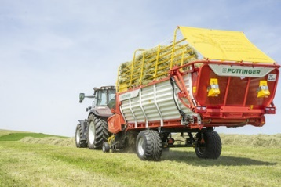 | 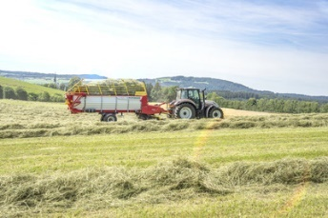
The new BOSS 3210 | BOSS 3210 makes a big impression on haymaking
https://www.poettinger.at/de_at/newsroom/pressebild/67634 | https://www.poettinger.at/de_at/newsroom/pressebild/67630
More printer-friendly photos are available at: https://www.poettinger.at/presse

